**Flask Multi-Page Web App**

**Project Overview:**

This is a simple multi page web application that demonstrates:

* Flask routing
* HTML templating
* Form handling (POST/GET)

**Technologies used:**

* Flask (Python micro web framework)
* HTML5
* CSS (inline)

**What is it all about:**

The app allows user to:

* Navigate between multiple pages (Home, About, Contact).
* Enter their name and get a personalized greeting.
* Submit a contact form (email and message).
* See a unified layout with consistent design.

**How it Works:**

* User visits / (home page) sees a welcome message and a form to enter their name.
* User submits name via POST redirected to “/greet”, which displays personalized greeting.
* User navigates to “/about” sees app information.
* User navigates to “/contact” fills and submit a contact form.

**Screenshots:**

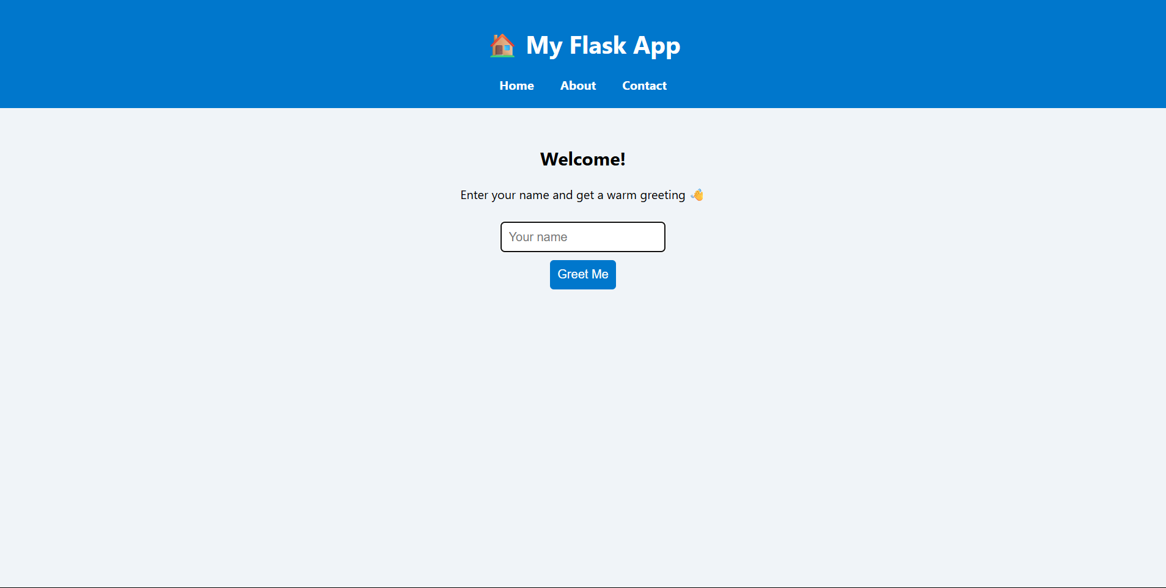

Fig: Home Page

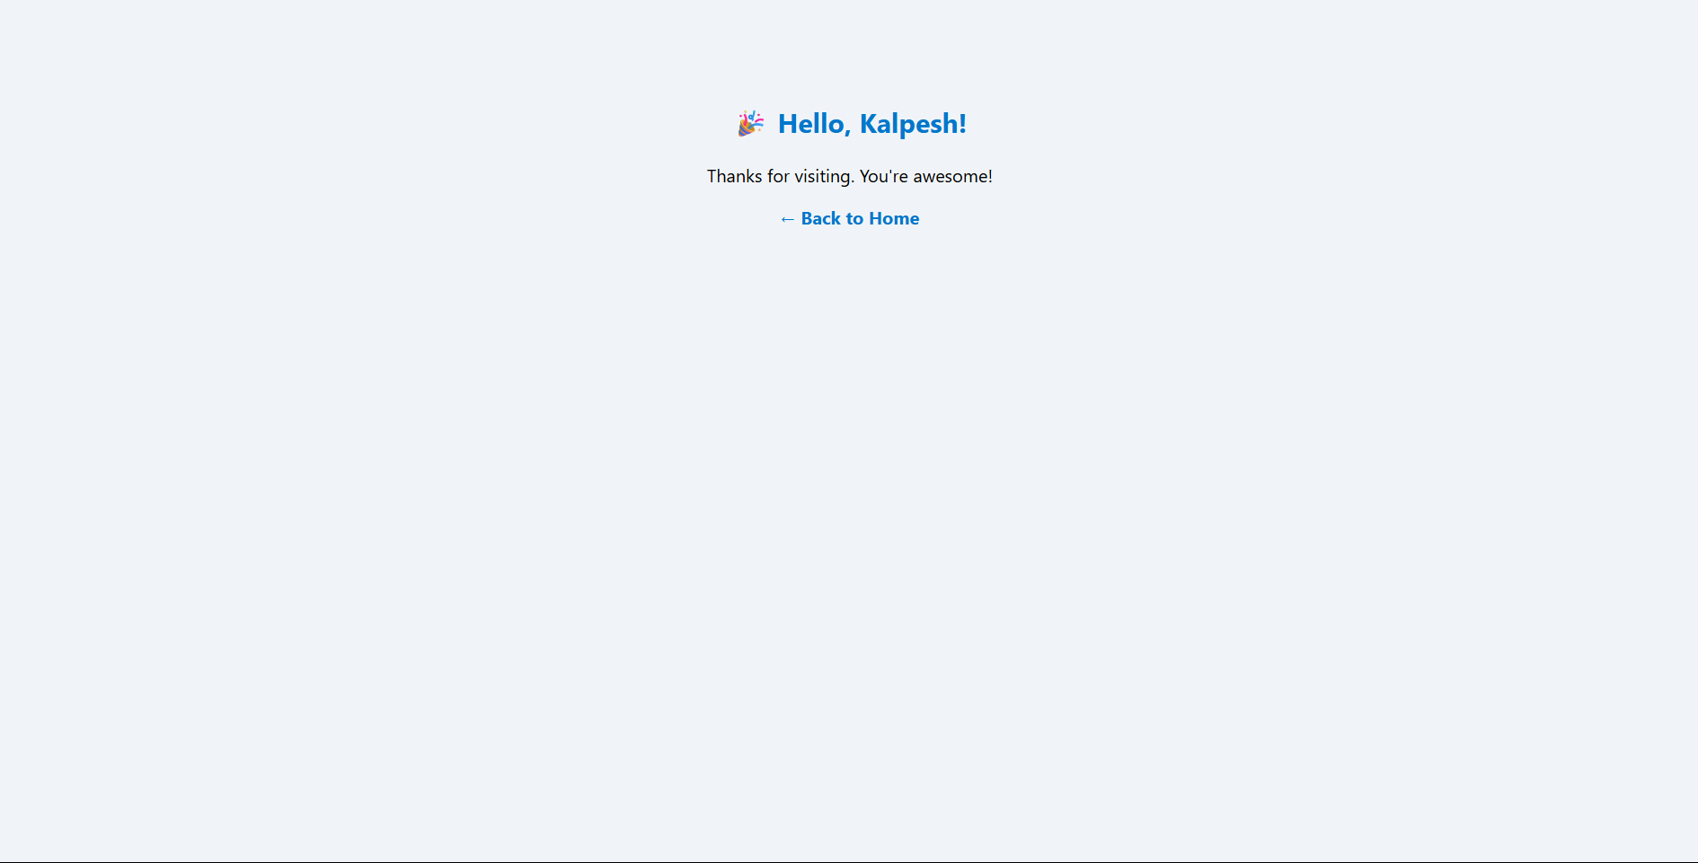

Fig: Greet Page

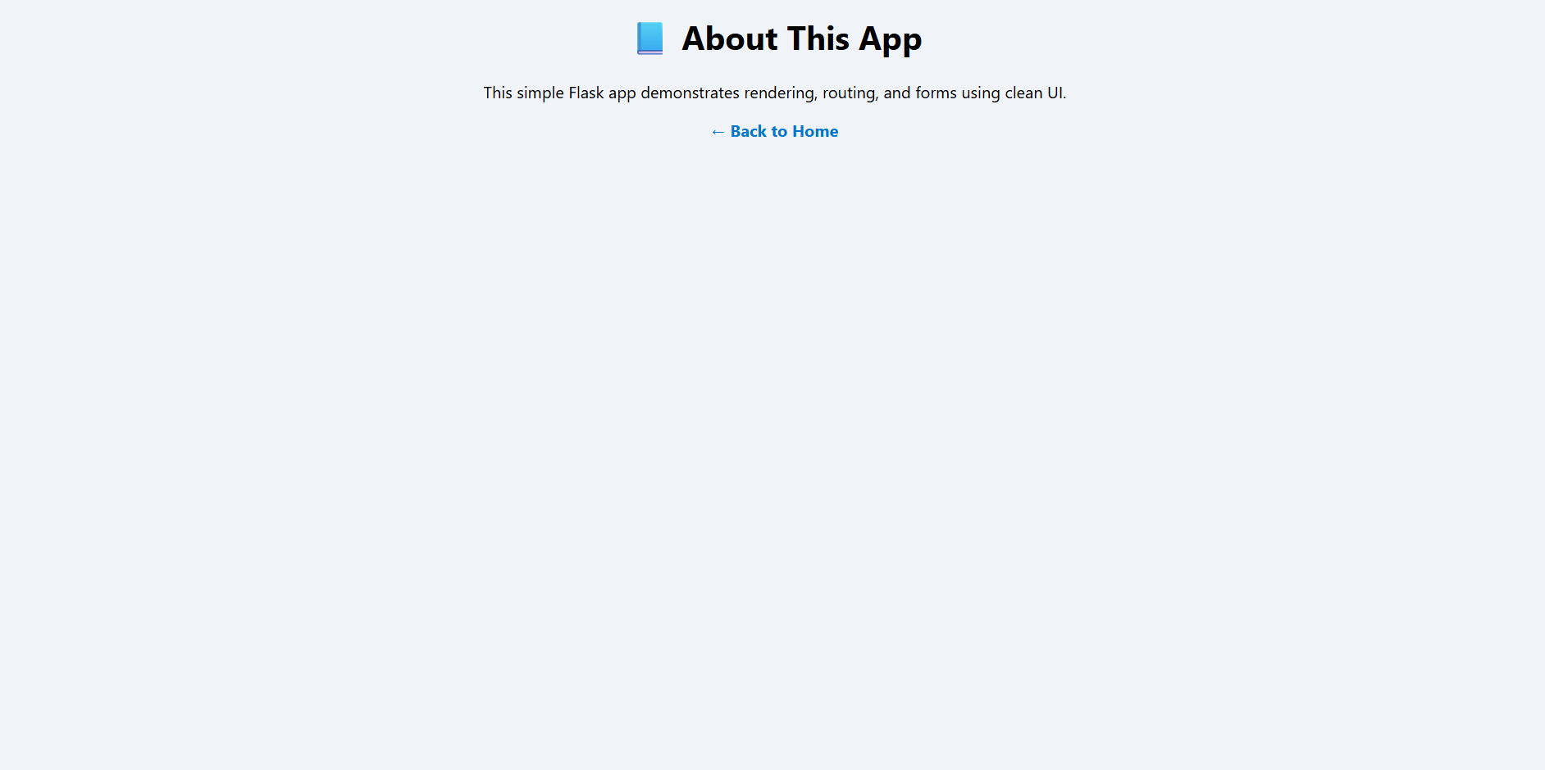

Fig: About Page

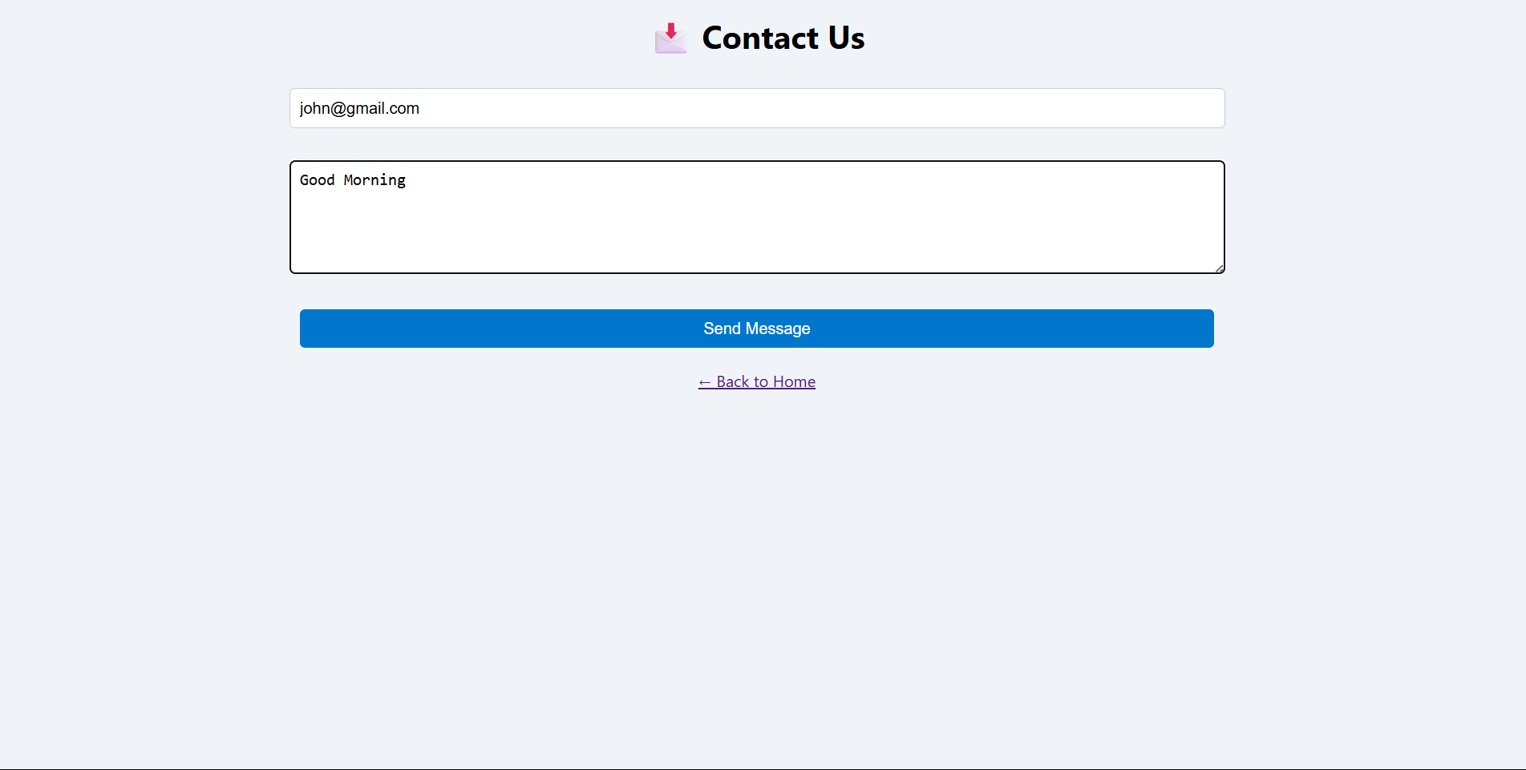

Fig: Contact Page